Your Name: Rachel Vredenburg
Title of Lesson: “Conversation and Art: An Expansion of Creativity”
Grade Level and Number of Students: Grade 10, Art II; 20 students
LESSON RATIONALE Description of what this particular lesson addresses and why is it important to teach this content (this is not procedural as that will be in the scripting section) Description of what the individual lesson is about including the big idea and why it is important for students to learn this information. Identify specific art processes and what is learned by this and its importance. Include specific artists and the importance of introducing these to students (min-500 words)
After extensively practicing foundational and technical methodologies that focus on the elements and principles for creating art in their previous courses, students will explore the importance of expressing meaning in art. It is important to consider the big idea of symbolism as students use art to create a visual conversation with viewers and the fluency of this visual language is instrumental to the investigation, as well as the interaction with viewers. By analyzing symbolism in both their own works, and the works of professional artists, students will exercise creative thinking and apply this meditative process to the use of symbols in their everyday lives. Social issues are constantly covered on news networks and social media; therefore, it is important for students to understand the contemporary and historical symbolism associated with individual causes.
Next, students will research an issue that personally resonates with them. This might include issues of race, LGBTQ+ justice, ecological issues and more. This investigation process is extremely important as students will further engage with current social issues that inevitably surround them and develop their own opinions upon researching their chosen topics. This research will directly impact their choice of subject. This is an important skill to have in the current digital age as there is plenty of misinformation available and they will have to use digital literacy skills to decipher the facts and formulate their own opinions.
Further, another characteristic of this project is the use of watercolor. This is a notoriously challenging medium to reflect the challenges faced by society in regard to social issues. By using this free-flowing medium, that is somewhat difficult to control, students will exercise problem solving as well as creative thinking skills to overcome this difficult situation. In addition to their symbolic subject matter, students will symbolically master the unpredictability that accompanies social activism by using a free-flowing medium to create insightful works of art to share with the school community. Similarity, by using this somewhat transparent medium, students will develop a sense of adaptability and dedication within themselves which is useful when confronting social issues as different situations require different approaches.
The chosen artists are strikingly different and with good reason: Anne Barron uses watercolor to depict endangered species and advocate for the conservation and environmental awareness. By partnering with the Artists for Conservation (AFC) she creates intense meaning and call to action in her works. This is important for students to acknowledge the impact of the art after the making process is complete, based on the meaning one creates through the work itself. Similarly, Kara Walker draws attention to issues of race and sexuality, but does so using a more drastic approach, for instance, her monumental work Sugar Sphinx draws attention to issues of race as it is a monumental symbol of power, like the sphinx, and uses sugar as a symbol of slavery in the business of sugar refinery. While these artists both offer support for their respective causes, they do so differently and though drastically different symbolism. Students will recognize the different portrayals of activism and synthesize their own project samples after observing multiple artist examples.
Process (printmaking, photo, sculpture, ceramics, fiber arts, painting, drawing) more specifically? ie: block printing, self portraits, wire manipulation, coil pots, felting, watercolors, graphite.
Watercolor, with metallic watercolor accents.
ARTISTS (include brief bio; name, art movement, medium, training, born/died, big idea etc.)
Anne Barron: A member of the Artists for Conservation (AFC) she is a Shetland-based artists who works with a variety of media, including watercolor, in order to draw attention to the issue of conservations which is dear to her. Her work, through painting endangered species reflects the mission of AFC “to support wildlife and habitat conservation and environmental education through art that celebrates nature” (Wild About Art, 2024). Largely self-taught, she is inspired by her love of animals and has raised a substantial amount of money to protect them (Artists for Conservation, 2024).
Kara Walker: “Walker demands that we examine the origins of racial inequality, in ways that transcend black and white” (The Art Story, 2016). For instance, she uses the monumental symbol of the sphinx and translates it into a powerful, Black woman. “Walker received a bachelor’s degree (1991) from the Atlanta College of Art and a master’s degree (1994) from the Rhode Island School of Design, where she began working in the silhouette form...” (Encyclopedia Britannica, 2018). She also noted in relation to her silhouette forms “’ “the silhouette says a lot with very little information, but that’s also what the stereotype does’” (Encyclopedia Britannica, 2018).
BIG IDEA: Symbolism
LEARNER OBJECTIVES: (what will the students be able to do? This should be a list- student will be able to conceive…? Develop…? Understand…? Create…? Imagine…? Evaluate…? Etc. Here you should have something about what they are making- such as students should be able to create a structure using what processes?)
-Students will think beyond the technical aspects of making to incorporate meaning into their works of art.
-Students will develop a relationship with a cause of their choosing using art as a means of action.
-Students will analyze the symbols that they have chosen and present their findings to the class during a mini critique.
Students will develop patience and adaptability as they use watercolor, a notoriously imprecise medium.
3 National Standards for Visual Arts (VAS) (list numbers and full description for each standard) https://www.arteducators.org/learn-tools/articles/219-national-visual-arts-standards-at-a-glance
VA:Cr3.1.Ia Apply relevant criteria from traditional and contemporary cultural contexts to examine, reflect on, and plan revisions for works of art and design in progress.
VA:Re.7.2.Ia Analyze how one’s understanding of the world is affected by experiencing visual imagery.
VA:Cn11.1.Ia Describe how knowledge of culture, traditions, and history may influence personal responses to art.
3 VA State Standards of Learning (SOL) in the arts: http://www.doe.virginia.gov/testing/sol/standards_docs/fine_arts/2013/visual_arts/std_finearts_visualarts.pdf
AII.6 The student will understand historical and cultural influences of art. a) Identify diverse historical and contemporary artists and artworks.
AII.7 The student will identify ways that art can be used to address community needs.
AII.12 The student will employ elements of art and principles of design to effectively communicate intended meaning in works of art and design.
ESSENTIAL QUESTIONS
- How does art contribute to the conversation of social issues?
- Does a visual conversation have more of an impact on viewers? Why or why not?
- How does meaning elevate art in comparison to technical skill?
________________________________________________________________
MATERIALS NEEDED FOR LESSON (be specific; how many of each item, what size paper, what color markers/paper, what kind of recycled materials, what size brushes, what kind of markers finepoint/broad tip, etc.?)
- Art supplies:
20-8x10” pieces of hot press watercolor paper, 20-medium sized round brushes with 1/2” bristles, 20-water cups, 10 regular RGB watercolor palettes, and 10-metallic watercolor palettes, 3-rolls of 1” painters tape, 20-11x14” Masonite boards as backers.

- Additional Materials (What books, images, websites, handouts, and other reference materials did you consult in planning this lesson and/or use in presenting it to your students?):
Art | Wild About Art | Scotland (wildaboutartgallery.com)
Artists for Conservation | world's leading artist group supporting the environment
18 Popular LGBTQ Symbols and What They Stand for (symbolsage.com)
Kara Walker Paintings, Bio, Ideas | TheArtStory
Kara Walker | Biography, Art, & Facts | Britannica
PowerPoint Presentation
VOCABULARY/DEFINITIONS (list 3 vocabulary words and their definitions that you will introduce in your lesson)
Activism: the policy or action of using vigorous campaigning to bring about political or social change.
Symbolism: an artistic and poetic movement or style using symbolic images and indirect suggestion to express mystical ideas, emotions, and states of mind, facilitate justice, etc.
Social Justice: justice in terms of the distribution of wealth, opportunities, and privileges within a society. Fairness in terms of social issues.
Cause: a principle, aim, or movement that, because of a deep commitment, one is prepared to defend or advocate.
Glazing: using the transparency of watercolor to overlay 2 separate layers, dried independently, and create a new color where the layers overlap.
MOTIVATING STUDENTS; PERSONAL and SOCIAL RELEVANCE (how does this lesson motivate students to want to participate or be interested in the content)
Students will utilize a choice-based approach that will allow each to select a topic that is personally relevant. Further, students will have the opportunity to research this topic and present their research to the class and receive feedback halfway through the project. Students will also have freedom to choose the animal they will use as a subject; provided they have research to support their choice and how this animal represents their cause. This open choice of subject and social issues leaves the students with a multitude of possibilities for customization. Since these choices make the final piece personally relevant, students will be more motivated to complete these pieces as they define their personal beliefs.
____________________________________________________________________
LESSON PROCEDURES
As part of the planning process, create a teaching example for your own learning purposes, and/or a series of process samples and visuals to use in teaching the lesson. Include 4-6 process images at end of lesson plan
- Teacher/Classroom Prep (List tasks that the teacher needs to accomplish before the lesson begins such as; print handouts, cut paper, divide art supplies, arrange tables for groups of four, arrange samples/student resources- be specific)
Teacher will take out all watercolor palettes, round brushes, paint cups, and sheets of paper and place them on the counter for easy accessibility. Teacher will make sure that there is enough backer boards of Masonite and 8x10” sheets of paper. They will cut more pieces of paper if necessary.
- LESSON SEQUENCE Also referred to as scripting or timing, work in the table below and include times. Be very specific from beginning to end. Remember to include material distribution, cleanup and closure. While writing keep in mind that the scripting must be detailed enough so that a substitute or colleague should be able to teach your lesson from the info you provide. Lessons for elementary are 45 minutes, middle school 1hour 20 minutes and high school 1 hour and 45 minutes.
Teacher Actions (include teacher questions and explanations) 10:30-12:15  10:30-10:33: greets students and instruct them to take a seat. | Expected Learner Actions  10:30-10:33 Students will respond to teachers greeting and take their seats.
10:35-10:50 introduce the lesson plan via the attached PowerPoint presentation. Make sure to pause and ask students to share examples of causes that are relevant to them to avoid potential teacher bias.  10:50-10:55 Go beyond the PowerPoint and conduct an in-class demo to show students how to blend or create glazes using watercolor. Student questions might include “How do I keep my colors from bleeding into a spot I don’t want them to?” “Allow that area to dry completely before going in with your next color if you want them to stay separate. Work on a different spot until then”  10:55-11:05 teacher will ask students to get out their Chromebooks and research an issue they are personally passionate about, then sketch 2 compositional thumbnails in their sketchbook. Teacher will walk around to help students brainstorm and consult on sketches.  11:05-11:15 Teacher will continue to walk around if students need help or advice on their sketches before starting their paintings. One student question might be “I know I want to do my project on LGBTQ+ issues, but I’m not sure where to start” “As you are researching look into what symbols are associated with the LGBTQ+ and specifically what aspect you want to explore.”  11:15-12:00 Teacher will remind students to begin with a light sketch and lighter tones. The teacher will walk around periodically and answer student questions like “this doesn’t look right; how could I fix it?” “Check the angles of your subject to make sure they are in proportion.”  Other reminders include working on larger areas with a larger brush and allowing layers to dry if students do not want mixing to occur.  12:00-12:15 Students will be reminded to use this last 15 minutes to clean up their tables, brushes, sign their sketched pieces along the tape, place pieces on the drying rack for tomorrow, and prepare for dismissal.  12:15 The bell rings and the teacher will wish the students a good day as they leave.  Day 2  10:30-10:35 Teacher will greet students as they come into the room and grab their palettes, paint, brushes, napkins, paint water and projects off the drying rack for the day before sitting at their assigned seats.  10:35-10:40 Teacher will remind students to continue working on their projects and that the first layers should be complete at this stage. “Any questions?” “Yes, mine looks really flat right now and I don’t want to badly represent my cause.” “Keep in mind we still need those darker shadows and saturated tones added to flesh out the dimensionality, keep layering and trust the process! You are doing great thus far, and we are still in progress!”  10:40-12:00: Teacher will remain available to help students if they get stuck but will allow the rest of the class time to finish these projects. Questions might include “How should I fill in the rest of my empty space?” “One option is to have a neutral or lightly textured background so that emphasis is placed on the objects, or a complementary color of one of the objects. Or use color drips that utilize the fluidity of the medium to create an interesting backdrop.”  12:00-12:15 Teacher will remind students that they will be presenting their in-progress pieces and receiving feedback tomorrow. “Make sure to put the wet paintings on the drying rack.”  12:15 the bell rings and teacher will say goodbye as students leave. “Have a great day!”  Day 3  10:30-10:35 Teacher will greet students as they come into the room and collect their supplies again and their projects from off the drying rack before sitting at their assigned seats.  10:35-11:00 Teacher will remind students to briefly present their projects. Teacher will ask each student what their thesis is and why they chose their subject. “Tell us a little about your piece, and what it represents…”  11:00-12:00: Teacher will remain available to help students if they get stuck but will allow the rest of the class time to finish these projects.  12:00-12:15 Teacher will remind students to begin cleanup and place finished projects in the drawer. Unfinished projects will be completed over the weekend for homework. “High quality photos and the artist statement are due Sunday night in Canvas.”  12:15 the bell rings and teacher will say goodbye as students leave. “Happy Friday and great work!” | 10:35-10:50 Students will pay attention to the lesson introduction and engage with the discussion by contributing potential issues that resonate with them. Common answers might include “Ecological conservation, ocean pollution, Black Lives Matter, Pride, and gun control.  10:50-10:55 Students will gather around the teacher at one of the tables so observe the demo. They will also ask any questions like “I’ve tried watercolor, but it always looks washed out, I really prefer acrylic.” “Watercolor is a methodical process, that’s part of the reason we are mastering the fluidity of the medium. The secret is to let each layer dry and really build up a few layers to create dimension.”  10:55-11:05 Students will research their topics and create a few compositional sketches in their sketchbooks.  11:05-11:15 Students will then sketch at least 2 options in their sketchbook to plan for their final pieces. Students will engage with the teacher during this planning stage and form connection with peers as they compare symbols and try to guess what their peers are trying to convey.  11:15-12:00 Students will gather brushes, water cups, napkins, watercolor palettes and begin to work on the beginning stages of the painting. Students will have the opportunity to consult with the teacher during this stage. “I have my sketch but I’m not sure what colors to incorporate.” “What colors are associated with your movement? LGBTQ is a great example of categorizing their croups with color schemes.”  12:00-12:15 Students will sign the tape placed along of their pieces and place them on the drying rack. Then they will have the remainder of class to wash their palettes and brushes.  12:15 The bell rings and students say goodbye to their teacher as they leave.  Day 2  10:30-10:35 Students will say hello as they enter the classroom, gather their supplies and paintings off the drying racks, and continue the layering process to build contrast and dimension.  10:35-10:40 Students will pay attention during the teacher’s reminders/announcements and ask any pertinent questions before they get started. For instance, “We are presenting our initial ideas tomorrow, right?” “Yes! They do not have to be completely done, just introduce us to your ideas. Good question.”  10:40-12:00 Students will work steadily on these projects, and they will have plenty of time to ask the teacher questions or obtain advice for certain areas they wish to improve. “I had a bit of black from my tiger stripes bleed into the background, how do I fix that? “Oh no! That’s ok, just grab a bit of napkin and blot the color, if it’s still wet it should come off for the most art. Be sure to let it dry more before you try that again, Chris.”  12:00-12:15 Students will begin cleaning their stations, place work either on the drying rack or in the drawer depending on if it is dry yet. Further, they will wash all brushes, paint cups, throw away napkins, and wipe any paint off the tables.  12:15 Students will say goodbye as they leave.  Day 3  10:30-10:35 Students will say greet the teacher and peers as they enter the classroom, gather their supplies and paintings off the drying racks, and continue the layering process to finalize their pieces.  10:35-11:00 Students will pay attention during the teacher’s reminders/announcements and take turns presenting their initial ideas. Some examples might include “I chose a panther because when I was doing my research, the movie Black Panther had become a symbol of the Black Lives Matter movement.” Or “I am doing a lavender rhinoceros as that was historically used as a symbol for homosexuality.”  11:00-12:00 Students will work steadily on their projects, and they will have plenty of time to ask the teacher questions or obtain advice for certain areas they wish to improve. “It’s almost done but I just don’t know how to make it look ‘finished.’” “It looks like your subject is super detailed, but you haven’t added any metallic yet, that will really shed some light on the fur!” “Ha…veryyy funny, but I can totally see that! I’ll add that and see if it ties my piece together.”  12:00-12:15 Students will begin cleaning their stations, place finished work in the drawer and take unfinished work home with them. Further, they will wash all brushes, paint cups, throw away napkins, and wipe any paint off the tables.  12:15 Students will acknowledge the homework assignment and say goodbye as they leave.
ADAPTATIONS AND RECOMMENDATIONS (Note Accommodations for Students with Special Needs as well as any classroom management strategies)
All students will have access to a subtitled version of the in-class demo video as well as a copy of the introductory presentation. Both will be uploaded to canvas. This will benefit students with a hearing impairment as well as students with a learning disability as they will be able to pause the directions/ presentations multiple times and read along with the directions. Students who need wheelchair access will be able to reach the provided supplies as the teacher will prep the classroom and put the supplies on the counter. There will also be plenty of room provided at their table so the chair will fit comfortably.
ASSESSMENT
A. Assessment: How will you collect information on what students gained from this lesson? How will you evaluate that information? (Refer back to Learner Outcomes to decide how you will know if students learned what you hoped they would learn)
Students will present their findings in-class and the teacher will be able to assess their understanding of the assignment as well as their overall findings. Constructive feedback will be given at this checkpoint to ensure students are on track. Ultimately, students will turn in preliminary sketches and upload final images to their canvas portfolio for grading. Students will also submit a typed, reflection paragraph (6-10 sentences) on Canvas that summarizes their experience, their findings, and the main idea of their piece for homework on the final day.

PROCESS IMAGES
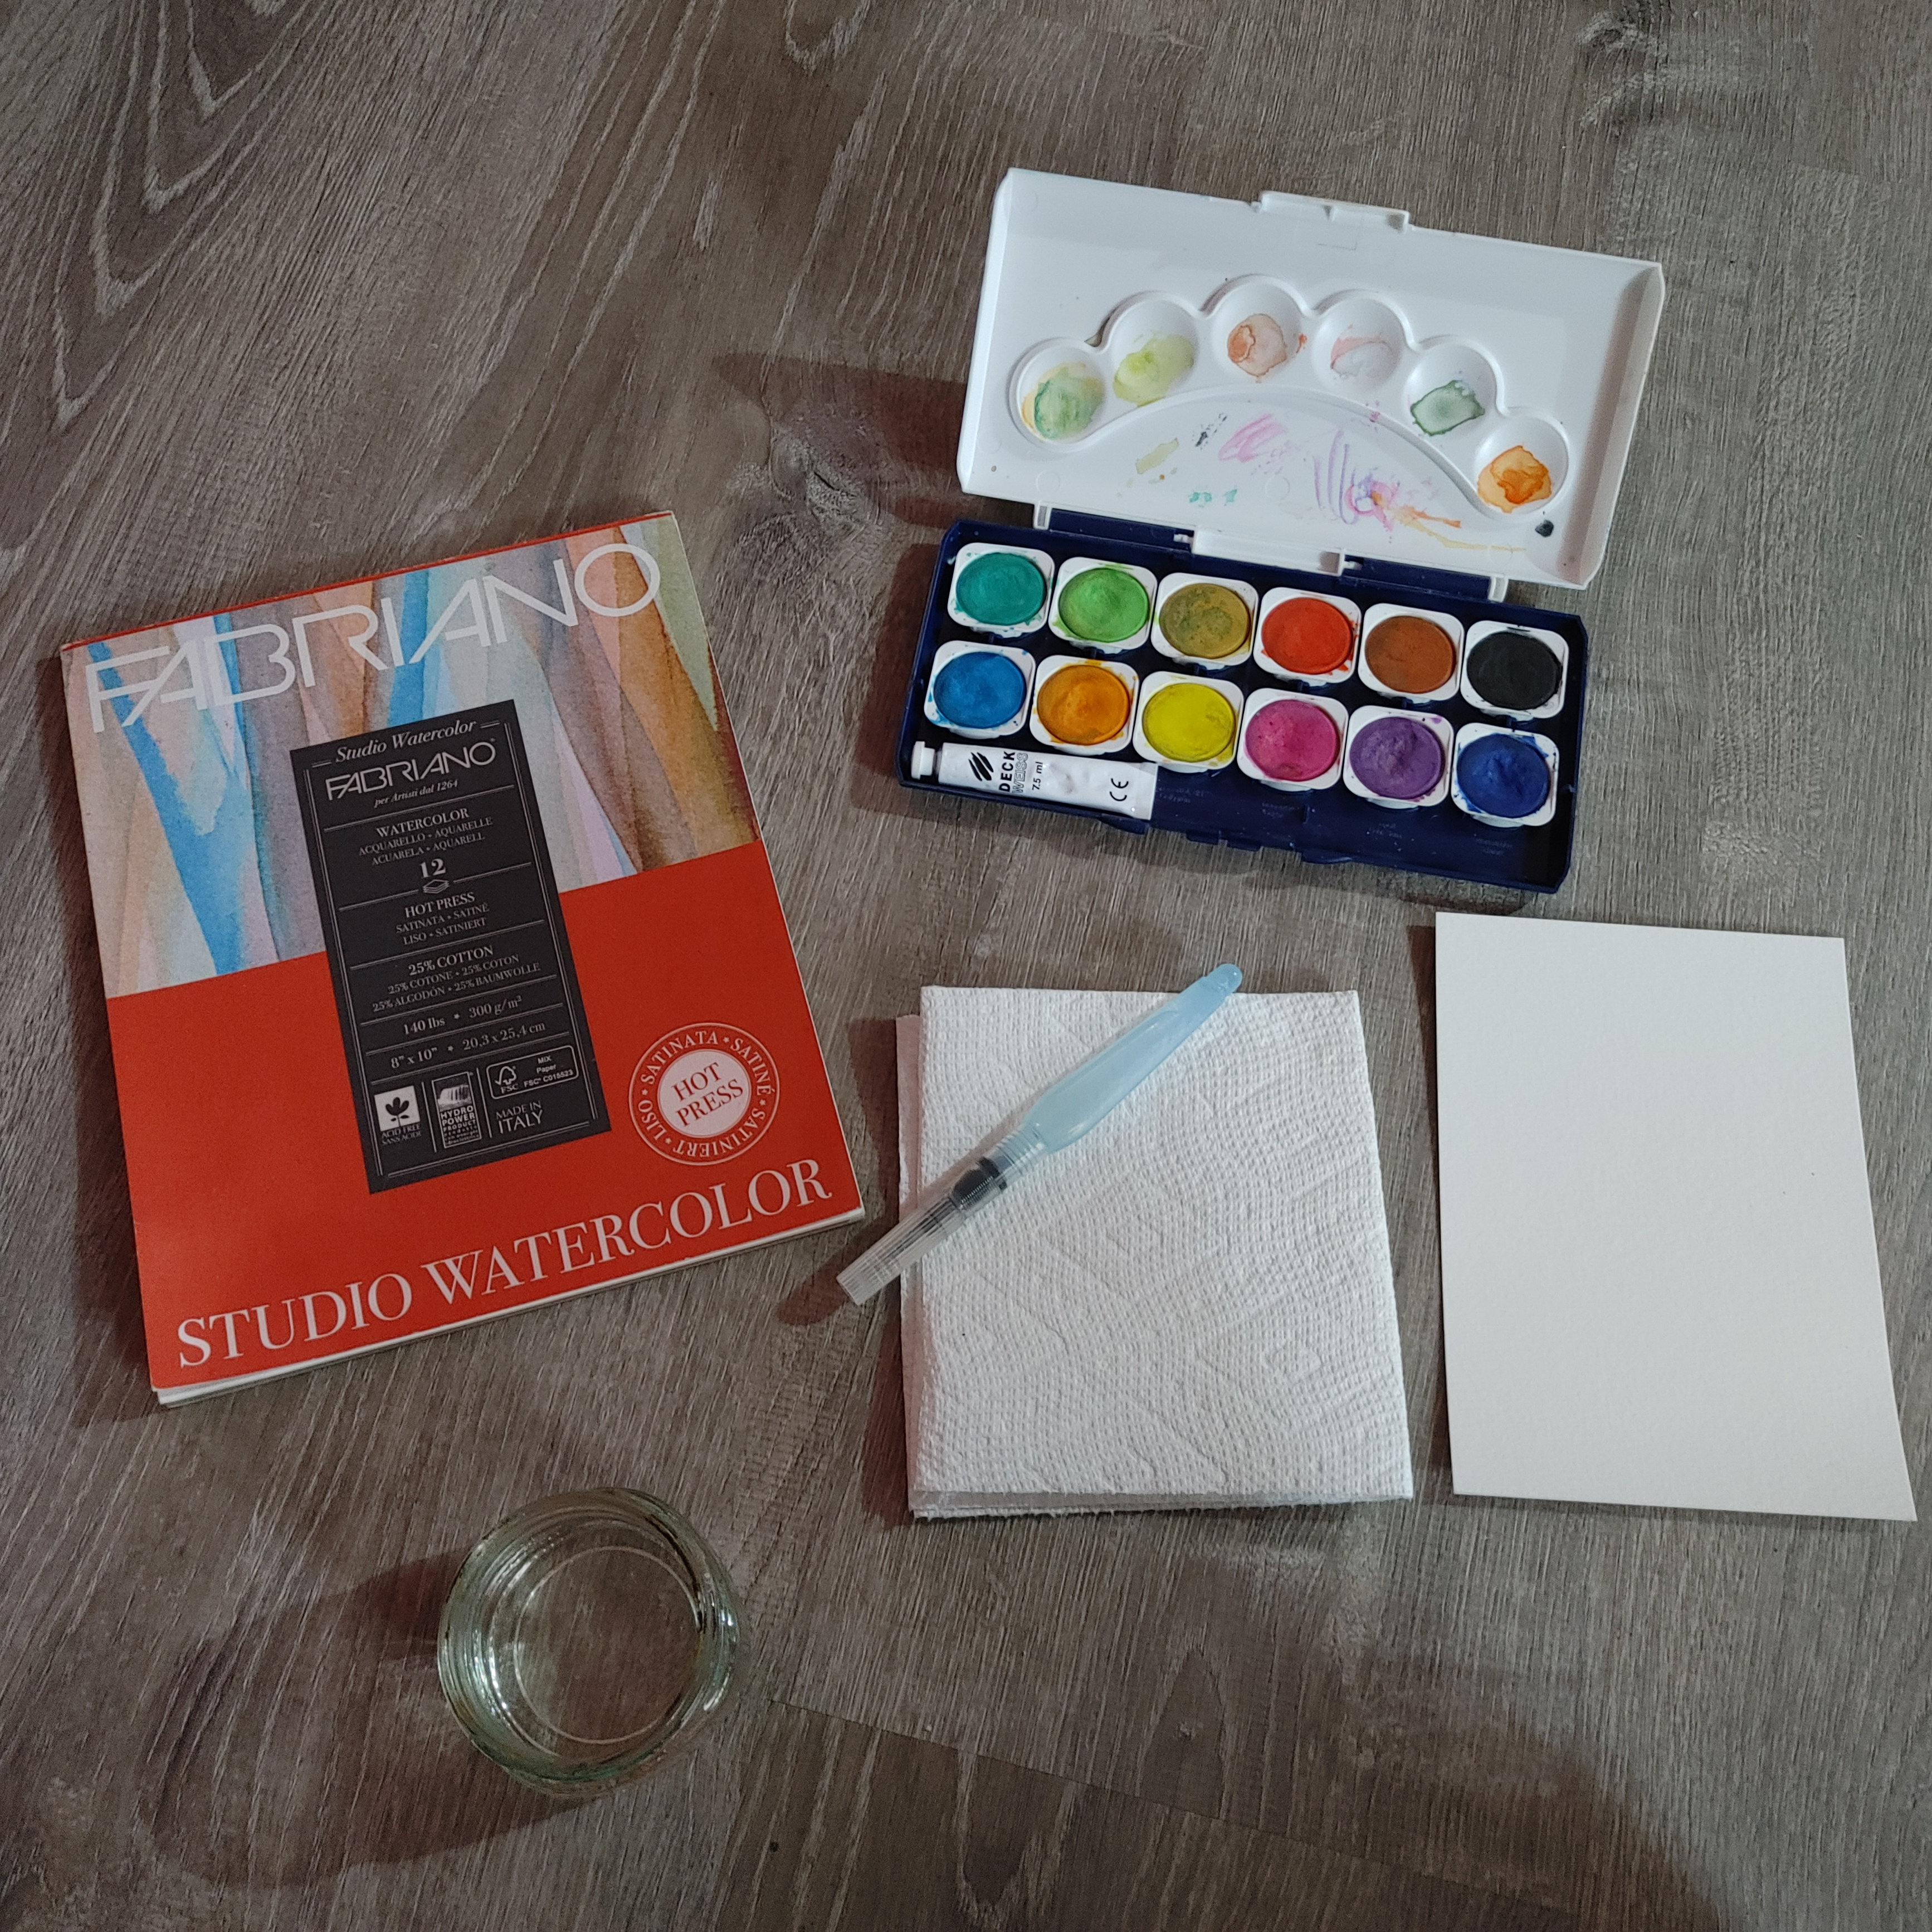
Step 1: Gather Supplies including paints, a reference, 2 brushes, a water cup, a watercolor palette, a painting surface, and blotting napkins.
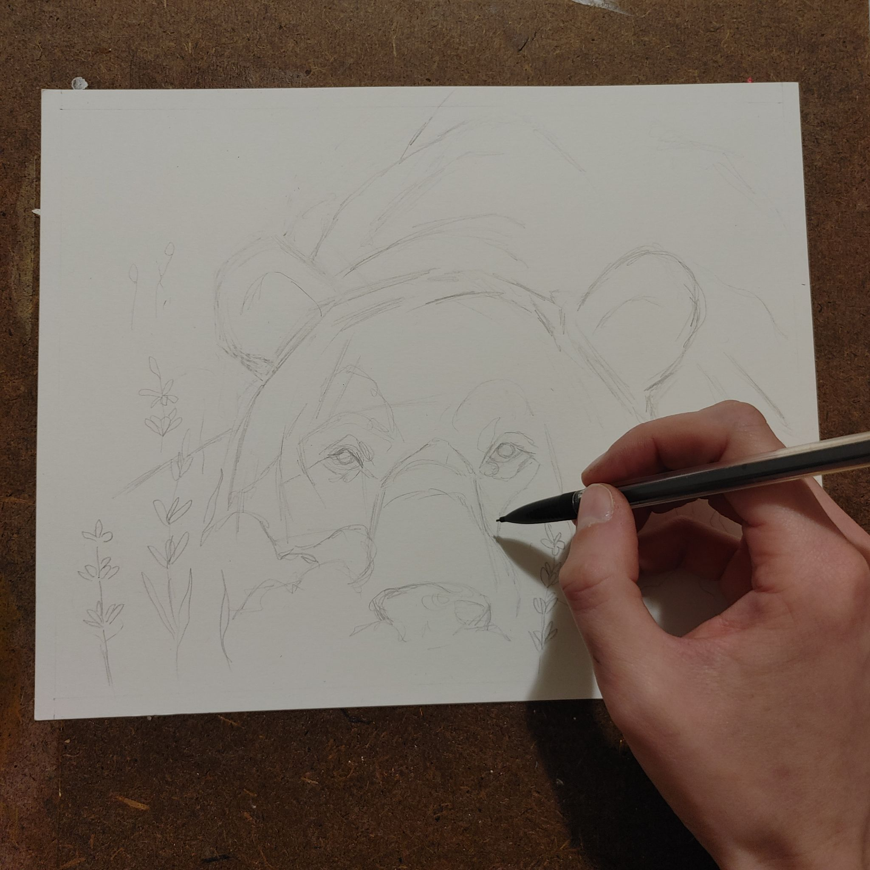
Step 2: Sketch out the subject using a pencil, on the watercolor paper. Emphasis is placed on proportion, but details will be added using the actual paint.
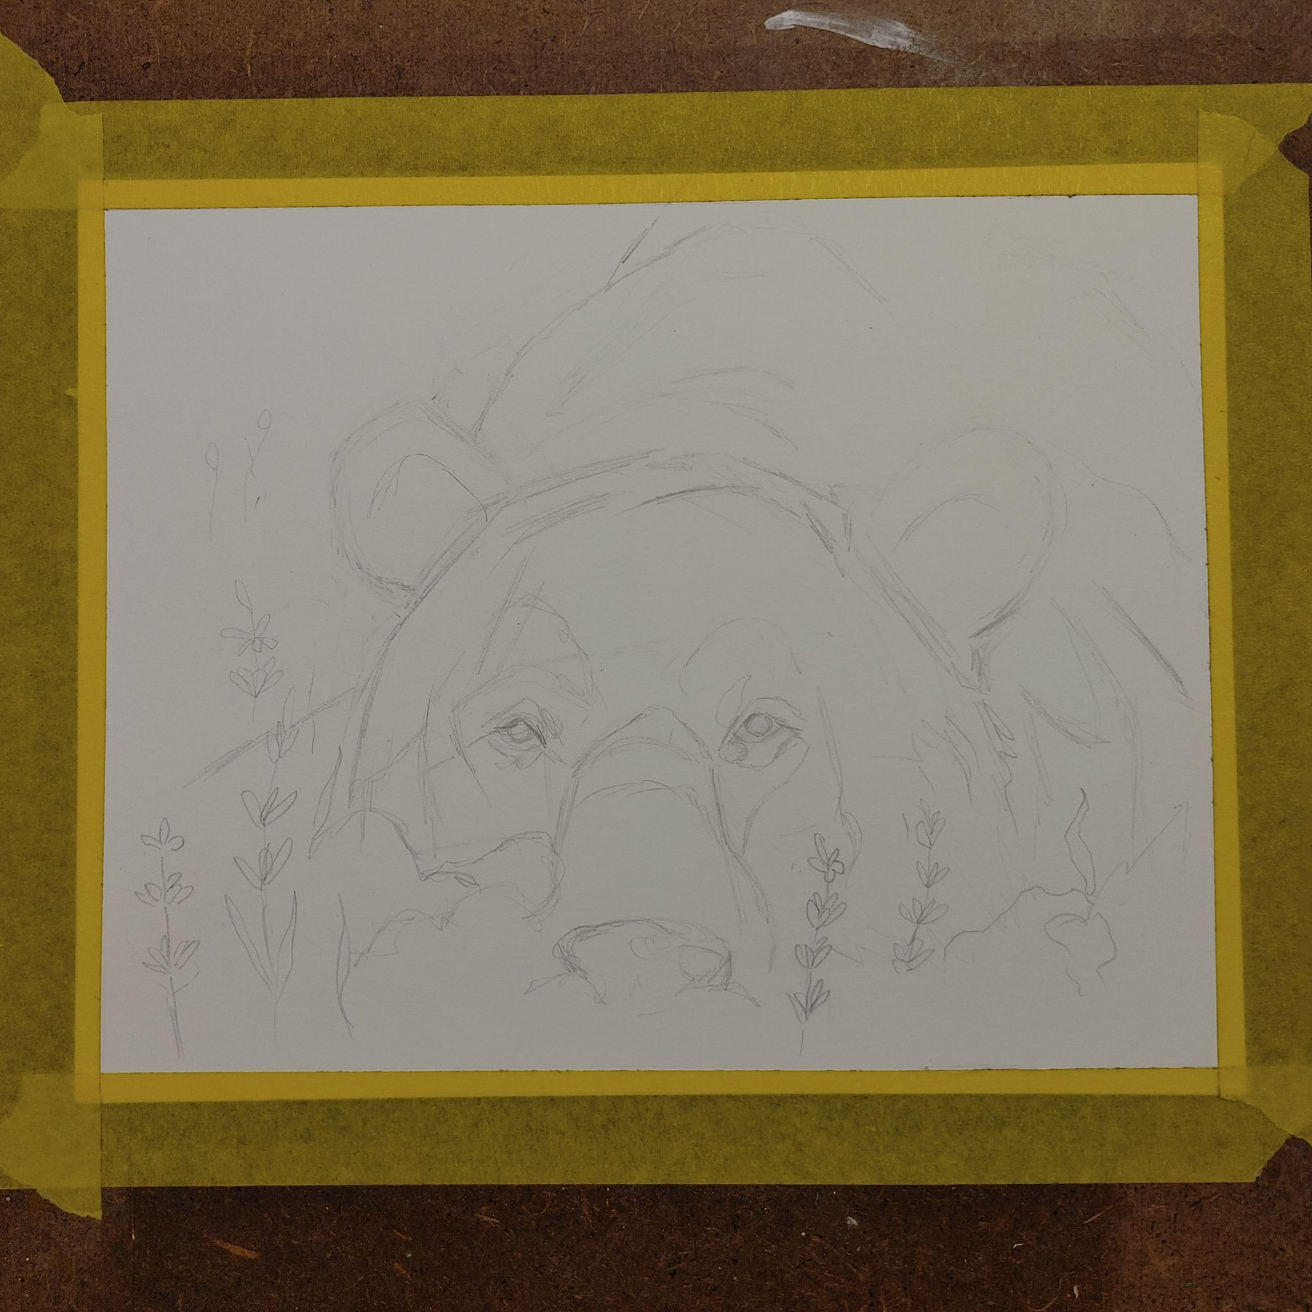
Step 3: measure and apply tape evenly to all sides to minimize warping.

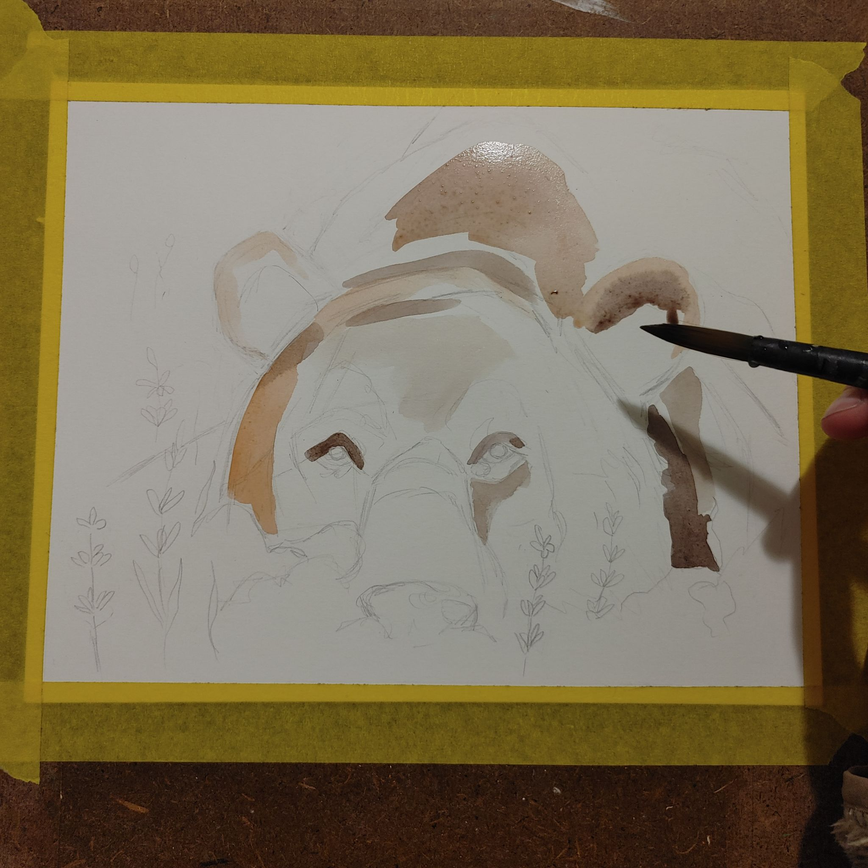
Step 4: Build up layers, paying attention to the shapes of shadows.
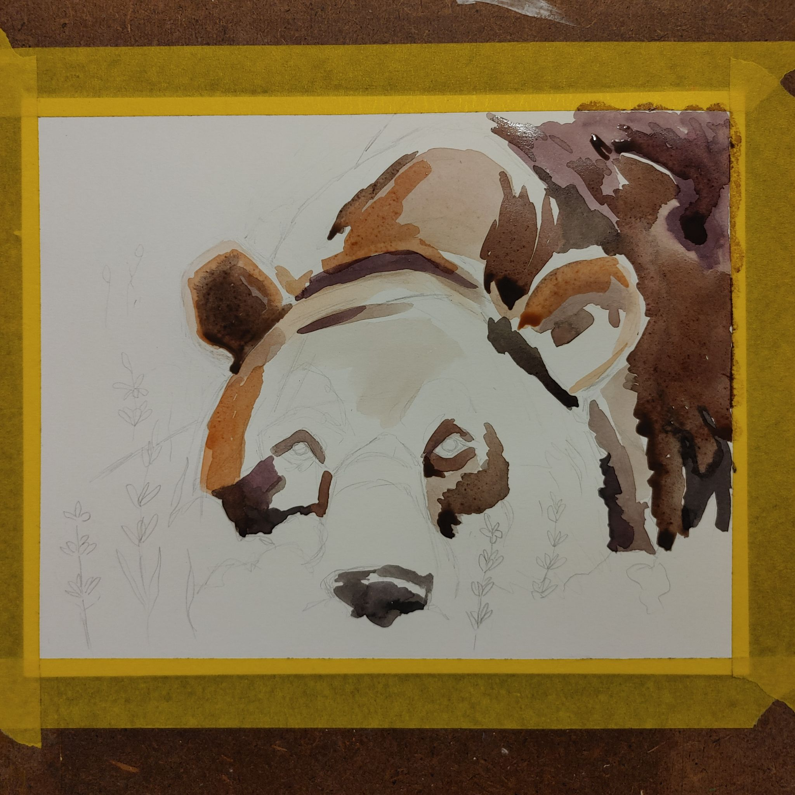
Step 5: continue the layering process to incorporate details including deep shadows and bright highlights.

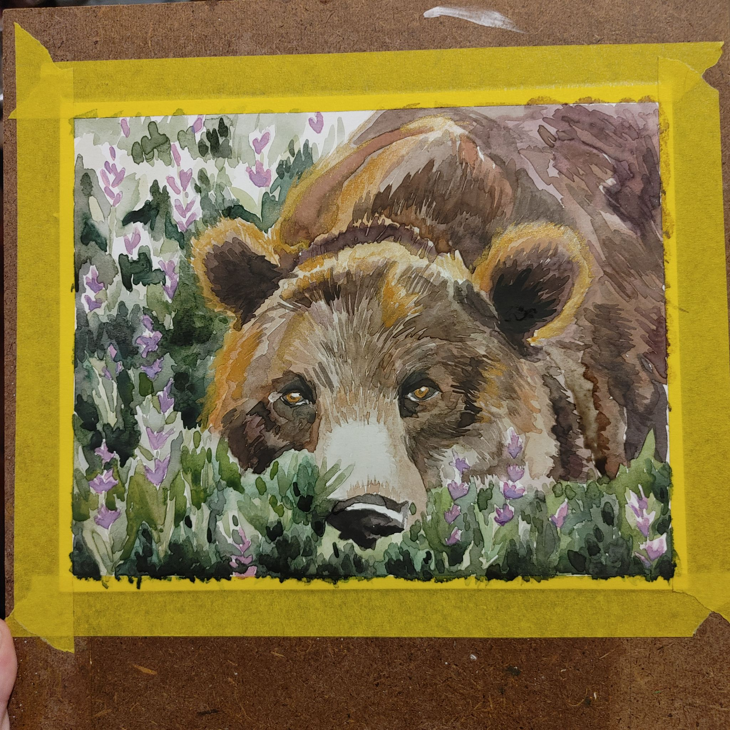
Step 6: Add highlights using metallic watercolors over the traditional watercolor areas.
Final Product!
References
Artists for Conservation. (2024). Artists for Conservation | world’s leading artist group supporting the environment. www.artistsforconservation.org. https://www.artistsforconservation.org/.
Encyclopedia Britannica. (2018). Kara Walker | Biography, Art, & Facts. In Encyclopædia Britannica. https://www.britannica.com/biography/Kara-Walker.
Rhys, D. (2023, March 24). 18 LGBTQ Symbols and What They Stand for. Symbol Sage. https://symbolsage.com/lgbtq-symbols-and-their-meaning/.
The Art Story. (2016, January 23). Kara Walker. The Art Story; The Art Story Foundation. https://www.theartstory.org/artist/walker-kara/.
Wild About Art. (2024). Wild About Art with Artist Anne Barron. Wildaboutart. https://www.wildaboutartgallery.com/.

