Rachel Vredenburg
Title of Lesson: “Nostalgia Through Association: Exploration, Reflection, and Connection”
Grade Level and Number of Students: 11th Grade, Art III, 20 Students
LESSON RATIONALE Description of what this particular lesson addresses and why is it important to teach this content (this is not procedural as that will be in the scripting section) Description of what the individual lesson is about including the big idea and why it is important for students to learn this information. Identify specific art processes and what is learned by this and its importance. Include specific artists and the importance of introducing these to students (min-500 words)
The big idea behind this lesson is exploring Nostalgia and how it functions in the collective memory. While individual experience is ultimately unique to each student, as they each have a different background to explore and share with one other, many of them share the same geographical location and similar age. Therefore, there will likely be similarities, or at least familiarities, among each class. For instance, as students bring in found items, or select some from those provided by the teacher, they build connections among peers due to either familiarity of students with a classmate’s item, or unfamiliarity that piques their curiosity. Regardless, interactions such as these, especially due to the personal nature of the objects and what they mean to students, can spark conversations as students compare their experiences. Further, students will begin to understand that these connections create a shared experience within the class as well as within the generation overall. By creating art that unifies these objects within one composition, students will create a sort of time capsule filled with personal meaning.
This artmaking process is important for several reasons. Firstly, students will explore the layering technique of painting to escape perfectionism and analyze their own past in a methodical, layered way. By using observational drawing skills, students will pay attention to detail. This skill is directly applicable to other facets of the students’ lives such as editing essays or writing a resume as they prepare for post-secondary education and work. Finally, not only are students using observational skills to create their projects, but they are also learning that there is the potential for meaning and joy in the seemingly ordinary. This is an important mindset to understand in order to bring a sense of wonder into one’s life. By recognizing beauty in the ordinary, the pressure to create art that is sensationally beautiful is removed so that actual progress in the making process can take place.
It is important to include modern, popular artists such as Sari Shryack, Guy Yanai, and Alai Ganuza because these artists bring vibrancy to the mundane through a variety of painting techniques. Furthermore, they are examples of artists that are actively engaged with their audiences as making art is a realistic part of their income. The notion that art is a viable career to those truly dedicated to the practice is one that is often overlooked as a career due to supposed impracticality. However, it is important to acknowledge that some artists, with the help of social media platforms and skillful marketing, are able to share their creations as an integral part of their lives. Finally, it is interesting to note the similarities in color palette used by these artists, especially due to their distance from one another as they reside in the US, Europe, and the Middle East, respectively. This is a great debate regarding the possible coincidence, versus of the globalization of styles, through the use of digital media that facilitates the sharing of artworks on a daily basis. This serves as another type oof connection that students may consider in addition to the connections within the smaller scale of the classroom.
Process (printmaking, photo, sculpture, ceramics, fiber arts, painting, drawing) more specifically? ie: block printing, self-portraits, wire manipulation, coil pots, felting, watercolors, graphite.
Students will use acrylic painting on canvas panel, using a painterly, layered technique.
ARTISTS (include brief bio; name, art movement, medium, training, born/died, big idea etc.)
Sari Shryack: “Born in 1991, Sari attended Drury University and studied under painting professor Todd Lowery; she graduated with a degree in Fine Arts in 2014” (Shryack, 2024). Based in Austin, Texas, Sari Shryack is a contemporary artist who runs a successful art business on Instagram called Not Sorry Art. She uses colorful and nostalgic subject matter to speak about consumerism and her experience growing up without the means to make “fine art.” She works in both heavy-body acrylic and oils.
Alai Ganuza: She is a Spanish artist who uses both oils and digital art to create colorful, imaginative depictions of mundane scenery including household items and stuffed animals. In 2020 she graduated from University of Basque Country with a degree in fine arts (Ganuza, 2024). She is a contemporary artist who is also prominent on social media and uses her platform to offer advice and share her skillset with interested learners.
Guy Yanai: Born in Israel and moved to New York, Yanai is a Jewish artist who uses simplistic palettes to “speak to moments of heartbreak and tragedy, but also to unbridled intimacy, evoking a nostalgia for what was perhaps lost during the lonely months of lockdown,” (Gergely 2021). This exemplifies a different, more tragic nostalgia and the different interpretations of the big idea. His paintings are rendered in oil on linen and he has exhibited in many solo shows on a global scale.
BIG IDEA: Nostalgia
LEARNER OBJECTIVES: (what will the students be able to do? This should be a list- student will be able to conceive…? Develop…? Understand…? Create…? Imagine…? Evaluate…? Etc. Here you should have something about what they are making- such as students should be able to create a structure using what processes?)
The student will create a vibrant acrylic painting that is not predicated upon perfection but is inspired by nostalgia.
The student will understand the importance of generational connection that can transcend other differences and unify the class or provide a lens to analyze and understand the diversity of the students in the classroom.
The student will evaluate symbolism in their work and the works of peers.
The student will develop an appreciation for the meaning of a work beyond a photorealistic quality.
3 National Standards for Visual Arts (VAS) (list numbers and full description for each standard) https://www.arteducators.org/learn-tools/articles/219-national-visual-arts-standards-at-a-glance
V A:Pr6.1.IIa: Make, explain, and justify connections between artists or artwork and social, cultural, and political history.
VA:Re.7.2.IIa: Evaluate the effectiveness of an image or images to influence ideas, feelings, and behaviors of specific audiences.
VA:Cn11.1.IIa: Compare uses of art in a variety of societal, cultural, and historical contexts and make connections to uses of art in contemporary and local contexts.
3 VA State Standards of Learning (SOL) in the arts: http://www.doe.virginia.gov/testing/sol/standards_docs/fine_arts/2013/visual_arts/std_finearts_visualarts.pdf
AIII.11 The student will cultivate cross-curricular connections with visual art.
AIII.14 The student will apply appropriate observation skills in the development of individual artistic work.
AIII.17 The student will refine personal stylistic choices for subject matter of artwork.
___________________________________________________________________
MATERIALS NEEDED FOR LESSON (be specific; how many of each item, what size paper, what color markers/paper, what kind of recycled materials, what size brushes, what kind of markers finepoint/broad tip, etc.?)
- Art supplies:
25 1” flat brushes, 25 small round detail brushes with 1/8th inch bristle diameter, Soho or Basics acrylic 11 colors in 120 ml bottles (cadmium red, cadmium yellow, phthalo green, phthalo blue, quinacridone magenta, titanium white, mars black, neon pink, neon green, neon orange, and neon yellow), 25 8x10” canvas panels, 10 recycled plastic containers to use as paint cups (family sized yogurt containers, mason jars, etc), 2 rolls of paper towels for blotting brushes, 20 paper plates for mixing, 25 rulers in case students need to grid images.

- Additional Materials (What books, images, websites, handouts, and other reference materials did you consult in planning this lesson and/or use in presenting it to your students?):
Not Sorry Art (sari.studio)
AlaiGanuza
Born in Israel, trained in NY, living in France, artist Guy Yanai defies labels | The Times of Israel
A PowerPoint presentation to introduce the students to the objectives.
VOCABULARY/DEFINITIONS (list 3 vocabulary words and their definitions that you will introduce in your lesson)
Triadic Color Scheme: Color scheme in which 3 colors, evenly spaced on the color scheme are used to create a sense of harmony.
Split Complementary Color Scheme: A dominant color paired with the two clors on either side of its complementary color.
Tetradic Color Scheme: Four colors spaced evenly on the color wheel.
Alla Prima: Technique of painting wet on wet.
Painterly: painting style that emphasizes texture and visible brushstrokes as opposed to photorealistic precision.
MOTIVATING STUDENTS; PERSONAL and SOCIAL RELEVANCE (how does this lesson motivate students to want to participate or be interested in the content)
The intention of this lesson in regard to motivating students, is to utilize the enduring idea of Identity and exploring one’s past. As students are at a pivotal and introspective age, as they approach the end of their secondary education, this ability to utilize independent thinking and choose their subject matter will create a personal connection to the piece and a lasting example of their art journey. Similarly, students will see the success of example artists that use color and are present on social media. Often, art students are asked “what will you do with this class?” Therefore, these real-work examples of artists that connect with their audiences over social medial will inspire and motivate these art III students. At the completion of the project, students will have a meaningful and personal piece that they can display in their own space, versus a work that is only relevant in the classroom.
____________________________________________________________________
LESSON PROCEDURES
As part of the planning process, create a teaching example for your own learning purposes, and/or a series of process samples and visuals to use in teaching the lesson. Include 4-6 process images at end of lesson plan.
- Teacher/Classroom Prep (List tasks that the teacher needs to accomplish before the lesson begins such as; print handouts, cut paper, divide art supplies, arrange tables for groups of four, arrange samples/student resources- be specific)
- Set all materials out on the counter so that students may gather the supplies they need to begin working after the teacher has presented the introductory information.
- Make sure that all tables are set up in groups of 4 so that students have plenty of room to begin working and that chairs are off the tables.
- Power on laptop and load their PowerPoint presentation so that they are ready to present the lesson once the bell rings.
- LESSON SEQUENCE Also referred to as scripting or timing, work in the table below and include times. Be very specific from beginning to end. Remember to include material distribution, cleanup and closure. While writing keep in mind that the scripting must be detailed enough so that a substitute or colleague should be able to teach your lesson from the info you provide. Lessons for elementary are 45 minutes, middle school 1hour 20 minutes and high school 1 hour and 45 minutes.
Teacher Actions (include teacher questions and explanations)  Class duration: 10:30-12:15 | Expected Learner Actions
*During previous class, ask students to bring in 3-5 items that remind them of their childhood experience including toys/trinkets.  10:30-10:33: greets students and instruct them to take a seat.  10:35-10:50 introduce the lesson plan via the attached PowerPoint presentation. Make sure to pause and ask students about their own examples of Nostalgia to build initial rapport/engagement/inspiration. Be sure to emphasize the painterly aspect so students do not feel constrained to photorealism.  10:50-10:55 expand the contents of the PowerPoint into a brief demo to show students how to check angles of a still life and sketch with paint rather than a pencil/charcoal. Student questions might include “can I use any neon color for the background?” “Yes, just make sure you use neon colors as vibrant undertones are part of this lesson.”  10:55-11:05 teacher will ask students to get out their found objects and assemble their still lives, then sketch 2 thumbnails in their sketchbook to take in the still life. As students set up, the teacher will walk around to converse and create an active dialog with students.  11:05-11:15 Teacher will continue to walk around if students need help or advice on their sketches before starting their paintings.  11:15-12:00 Teacher will remind students to begin with a neon undercoat and start sketching the still lives in paint, onto their canvas panels. Additionally, they will take a photo once their still lives are arranged, so they are able to remember where every object was placed the next day. The teacher will walk around periodically and answer student questions like “this doesn’t look right; how could I fix it?” “Check the angles of objects to make sure they are in proportion and round out the edges of the 8 ball.”  Other reminders include working on larger areas with a larger brush and really looking at the objects in front of them rather than allowing their brains to fill in the blanks. For instance, is that 8 ball just 2 colors? Or is it reflecting the blue from the windows and highlights from the overhead lights too?  12:00-12:15 Students will be reminded to use this last 15 minutes to clean up their tables, brushes, sign their sketched pieces on the back, place pieces on the drying rack for tomorrow, place still life items in the drawer if they choose and prepare for dismissal. Students will be told to bring still life items back tomorrow.  12:15 The bell rings and the teacher will wish the students a good day as they leave.  Day 2  10:30-10:35 Teacher will greet students as they come into the room and grab their palettes, paint, brushes, napkins, paint water and panels for the day before sitting at their assigned seats.  10:35-10:40 Teacher will remind students to reassemble their still lives and begin fulling in the undertones of the painting with muted colors. “Any questions?”  10:40-12:00: Teacher will remain available to help students if they get stuck but will allow the rest of the class time to finish these projects. Questions might include “My objects are coming together, but what should I do for the background?” “One option is to have a neutral so that emphasis is placed on the objects, or a complementary color of one of the objects.”  12:00-12:15 Teacher will remind students to wrap up their paintings and turn them in in the bottom drawer. If they are very thick and not dry yet, they will be turned in on the drying rack. The teacher will also remind students to take a well-framed photo to upload to canvas for homework/assessment.  Finally, the teacher will ask students to write a brief response to two questions as an exit ticket. 1-2 sentences per question.  “What is the point of exploring nostalgia in art?” And “Do you feel like you understand your classmates or societal symbolism more or less after this project?”  12:15 the bell rings and teacher will say goodbye as students leave | 10:30-10:33 Students will respond to teachers greeting and take their seats.  10:35-10:50 Students will pay attention to the lesson introduction and engage with the discussion by naming things that are personally nostalgic for them. This might include Pokémon cards, Fortnite, Pillow Pets, My Little Pony, etc.  10:50-10:55 Students will gather around the teacher at one of the tables so observe the demo. They will also ask any questions like “is there a set number of objects we need to include for full credit” “there isn’t a set number, but 3 or more would create an aesthetic composition, good question Daniel.”  10:55-11:05 Students will assemble their found objects onto an aesthetically balanced still life on the table in front of them.  11:05-11:15 Students will then sketch 2 options in their sketchbook to plan for their final product. Students will engage with the teacher during this planning stage as they form connections with peers by discussing the objects in front of them.  11:15-12:00 Students will gather pointing supplies and begin to work on the beginning stages of the painting including the primer coat of neon and the sketch in the colors of their choosing. Students will have the opportunity to consult with the teacher during this stage.  12:00-12:15 Students will sign the back of their panels and place them on the drying rack. Then they will have the remainder of class to wash their palettes and brushes. Students might leave their found objects in their drawer or take them home, but regardless they will need them tomorrow.  12:15 The bell rings and students say goodbye to their teacher as they leave.  Day 2  10:30-10:35 Students will say hello as they enter the classroom, gather their supplies and paintings off the drying racks, and use their Chromebooks to view the photos of their still lives from yesterday. From this photo, they will be able to reassemble their found objects into the same composition. Since their sketches will be done during day 1, they are using the objects more for color accuracy and value now that the proportions have been covered.  10:35-10:40 Students will pay attention during the teacher’s reminders/announcements and ask any pertinent questions before they get started. For instance, “You mentioned muted colors, how would I do that and why?” “Muted colors are toned down with complementary colors or neutrals, such as umber, and are used in this case to make the more saturated colors pop when layered on top! Good question.”  10:40-12:00 Students will work steadily on these projects and will be encouraged to engage with one another in an informal interview while they work. They will have ample opportunity to ask the teacher questions or obtain advice for certain areas they wish to improve.  12:00-12:15 Students will begin cleaning their stations, place work either on the drying rack or in the drawer depending on if it is dry yet. Further, they will wash all brushes, paint cups, throw away napkins, and wipe any paint off the tables.  Further, they will take a well-framed photo to submit to their digital portfolio on Canvas.  Finally, students will complete the exit ticket that consist of a short, written response to the two questions “What is the point of exploring nostalgia in art?” And “Do you feel like you understand your classmates more or less after this project?” as part of the assessment and discussion process.  12:15 Students will say goodbye as they leave.
ADAPTATIONS AND RECOMMENDATIONS (Note Accommodations for Students with Special Needs as well as any classroom management strategies)
For students with dexterity issues, larger brushes and larger scale canvas panels could be provided. For students with learning disabilities, there will be multiple deliveries of the information including demos, verbal instruction, and a PowerPoint they may access on Canvas for multiple exposures to the material. Classroom management strategies include teacher engagement and active conversations with students about their ideas to create excitement and rapport with students. This builds the connections among the class and the teacher as they share some of their nostalgic commonalities and compare stylistic techniques.
ASSESSMENT
- Assessment: How will you collect information on what students gained from this lesson? How will you evaluate that information? (Refer back to Learner Outcomes to decide how you will know if students learned what you hoped they would learn)
The assessment will include a brief exit ticket at the end of the second day, that ask the following questions: “What is the point of exploring nostalgia in art?” And “Do you feel like you understand your classmates more or less after this project?” Additionally, students will take quality photos and submit them to their online portfolio page on canvas as part of the assessment process.

Include 2-4 process images with captions from creating your teaching sample.

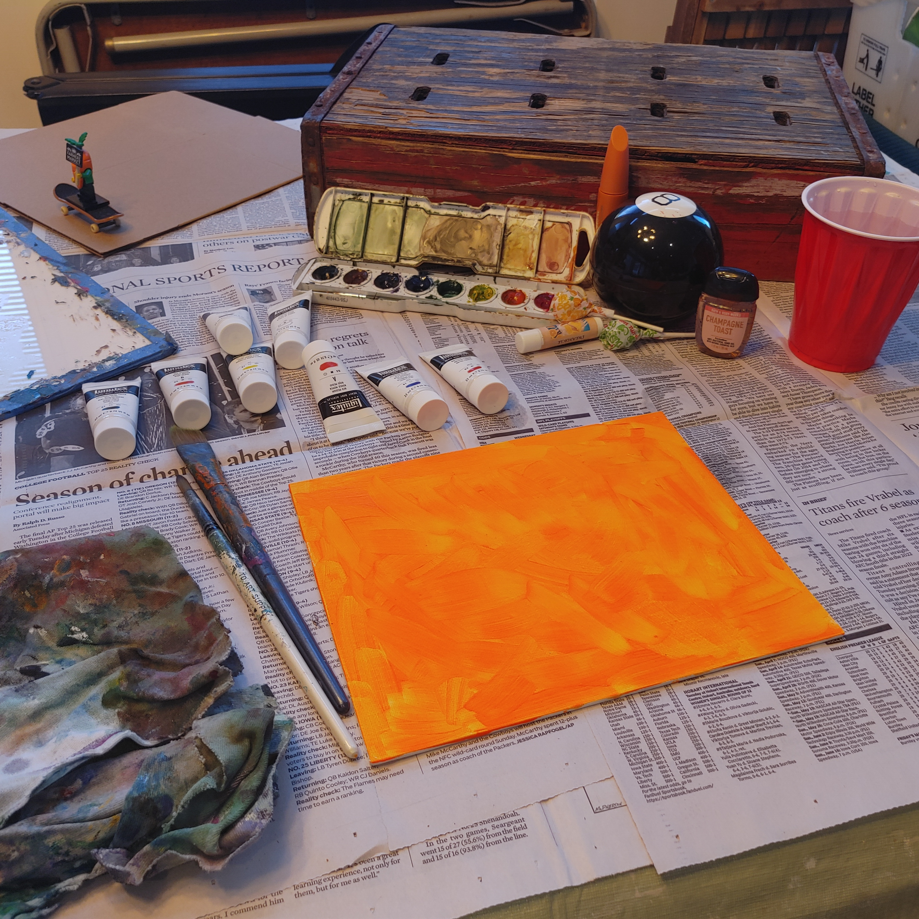
Step 1: Gather Supplies including paints, still life objects, 2 brushes, a water cup, a palette, a painting surface, and blotting napkins.

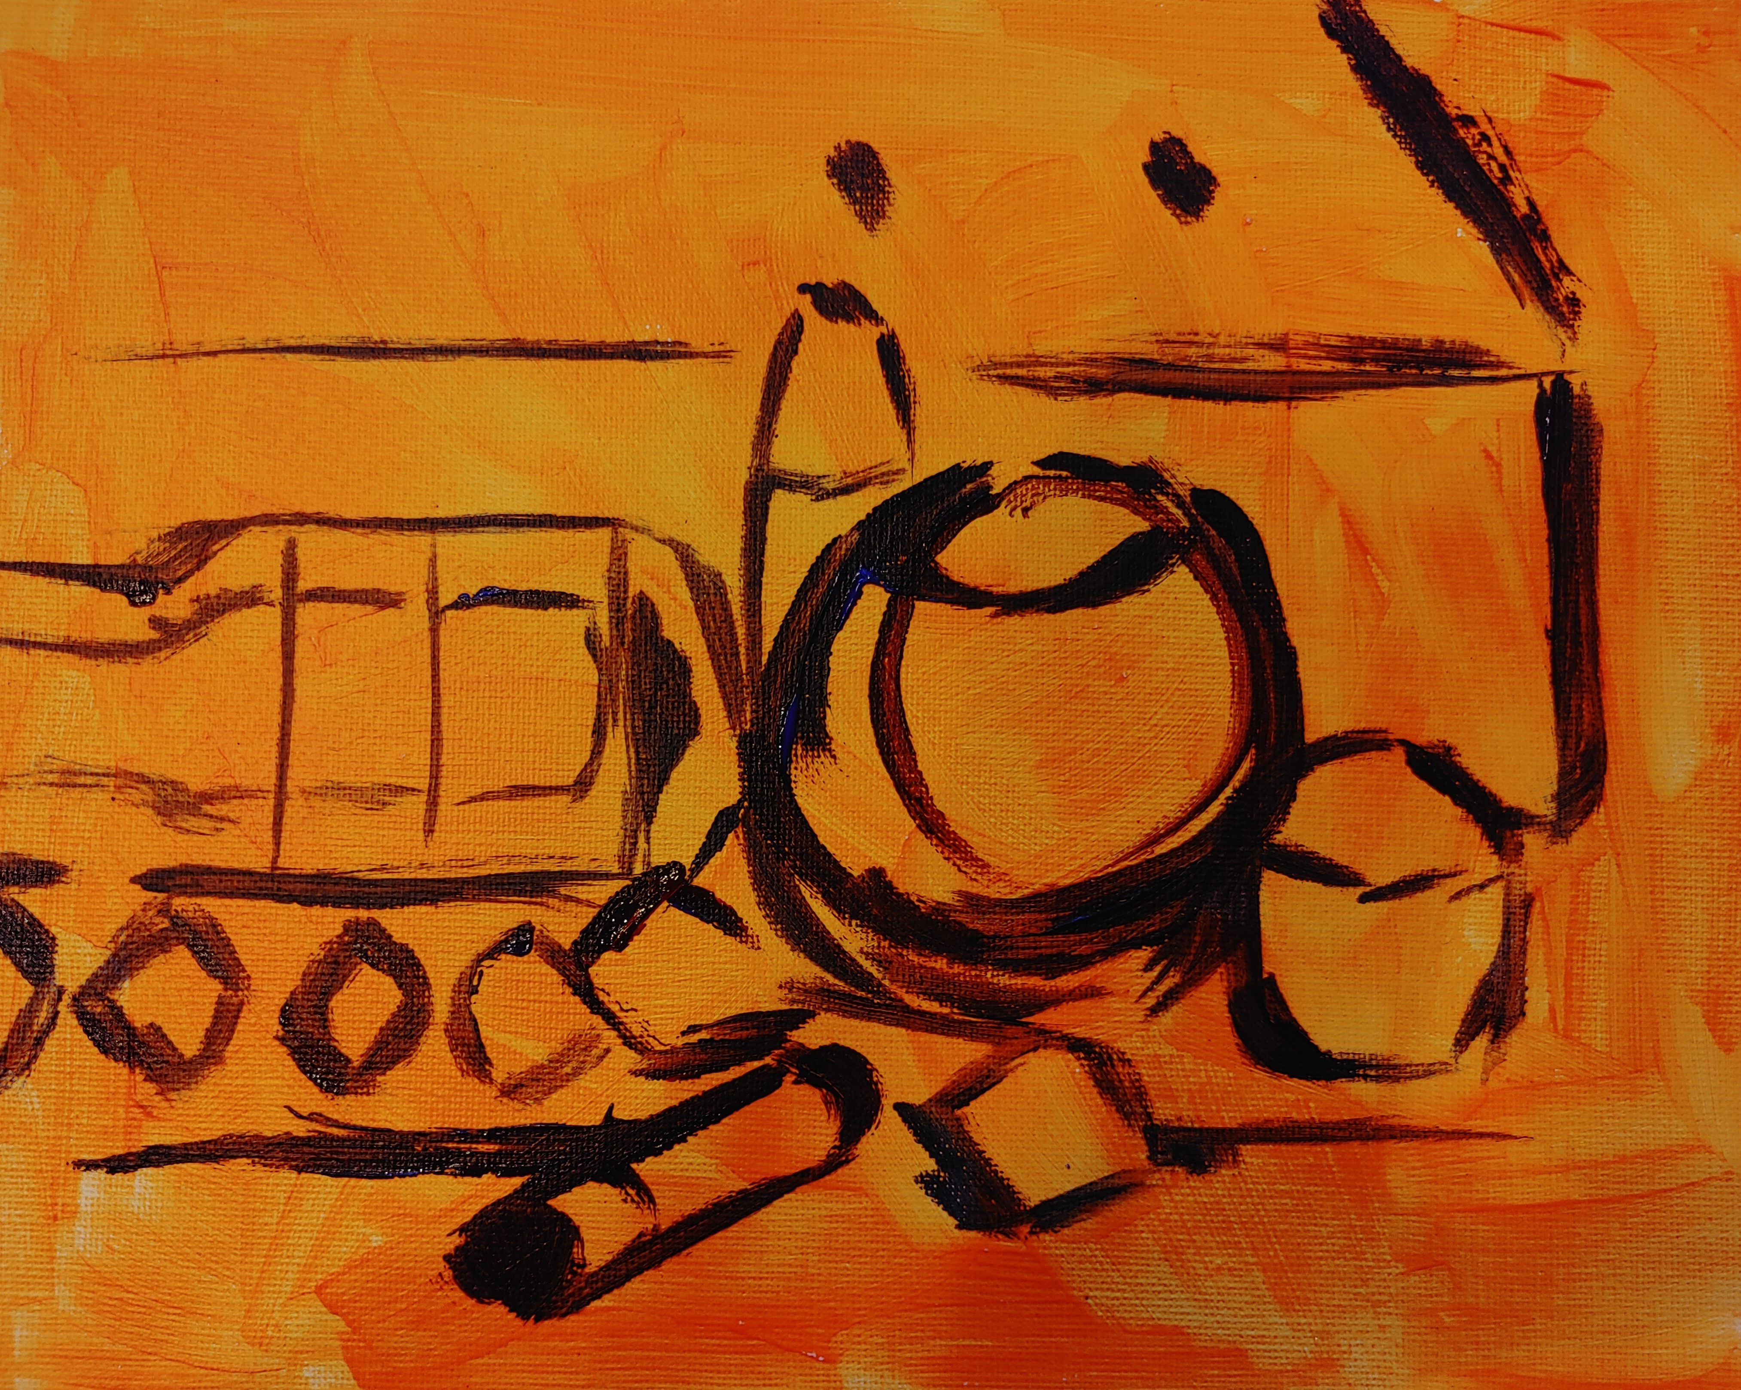
Step 2: Sketch out the still life using a contrasting paint color on top of the neon undercoat. Emphasis is placed on proportion, but gestural brush strokes rather than photorealistic precision.

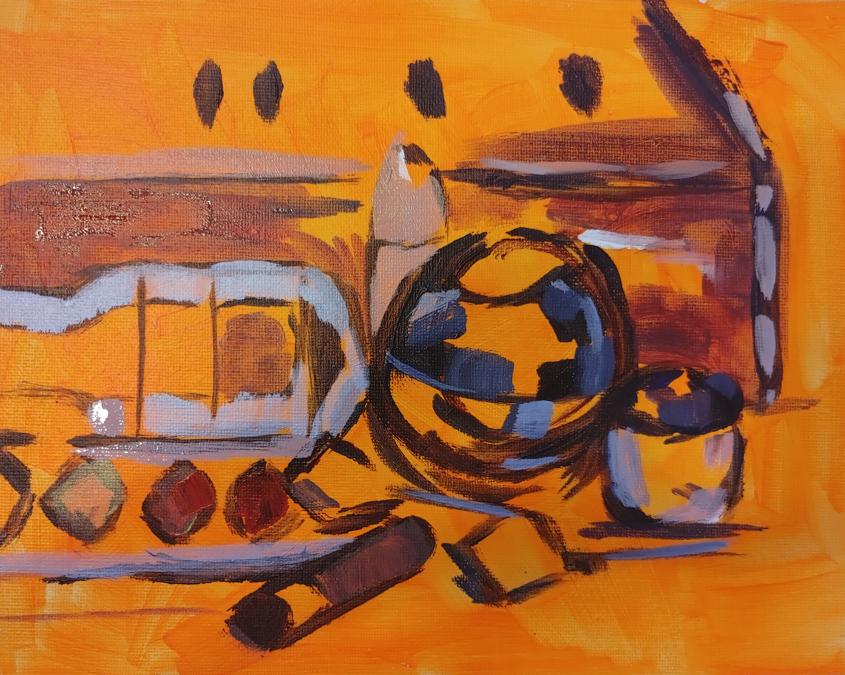
Step 3: Begin layering using the “color blocking” method to place muted hues in the correct places, paying attention to high-contrast areas.

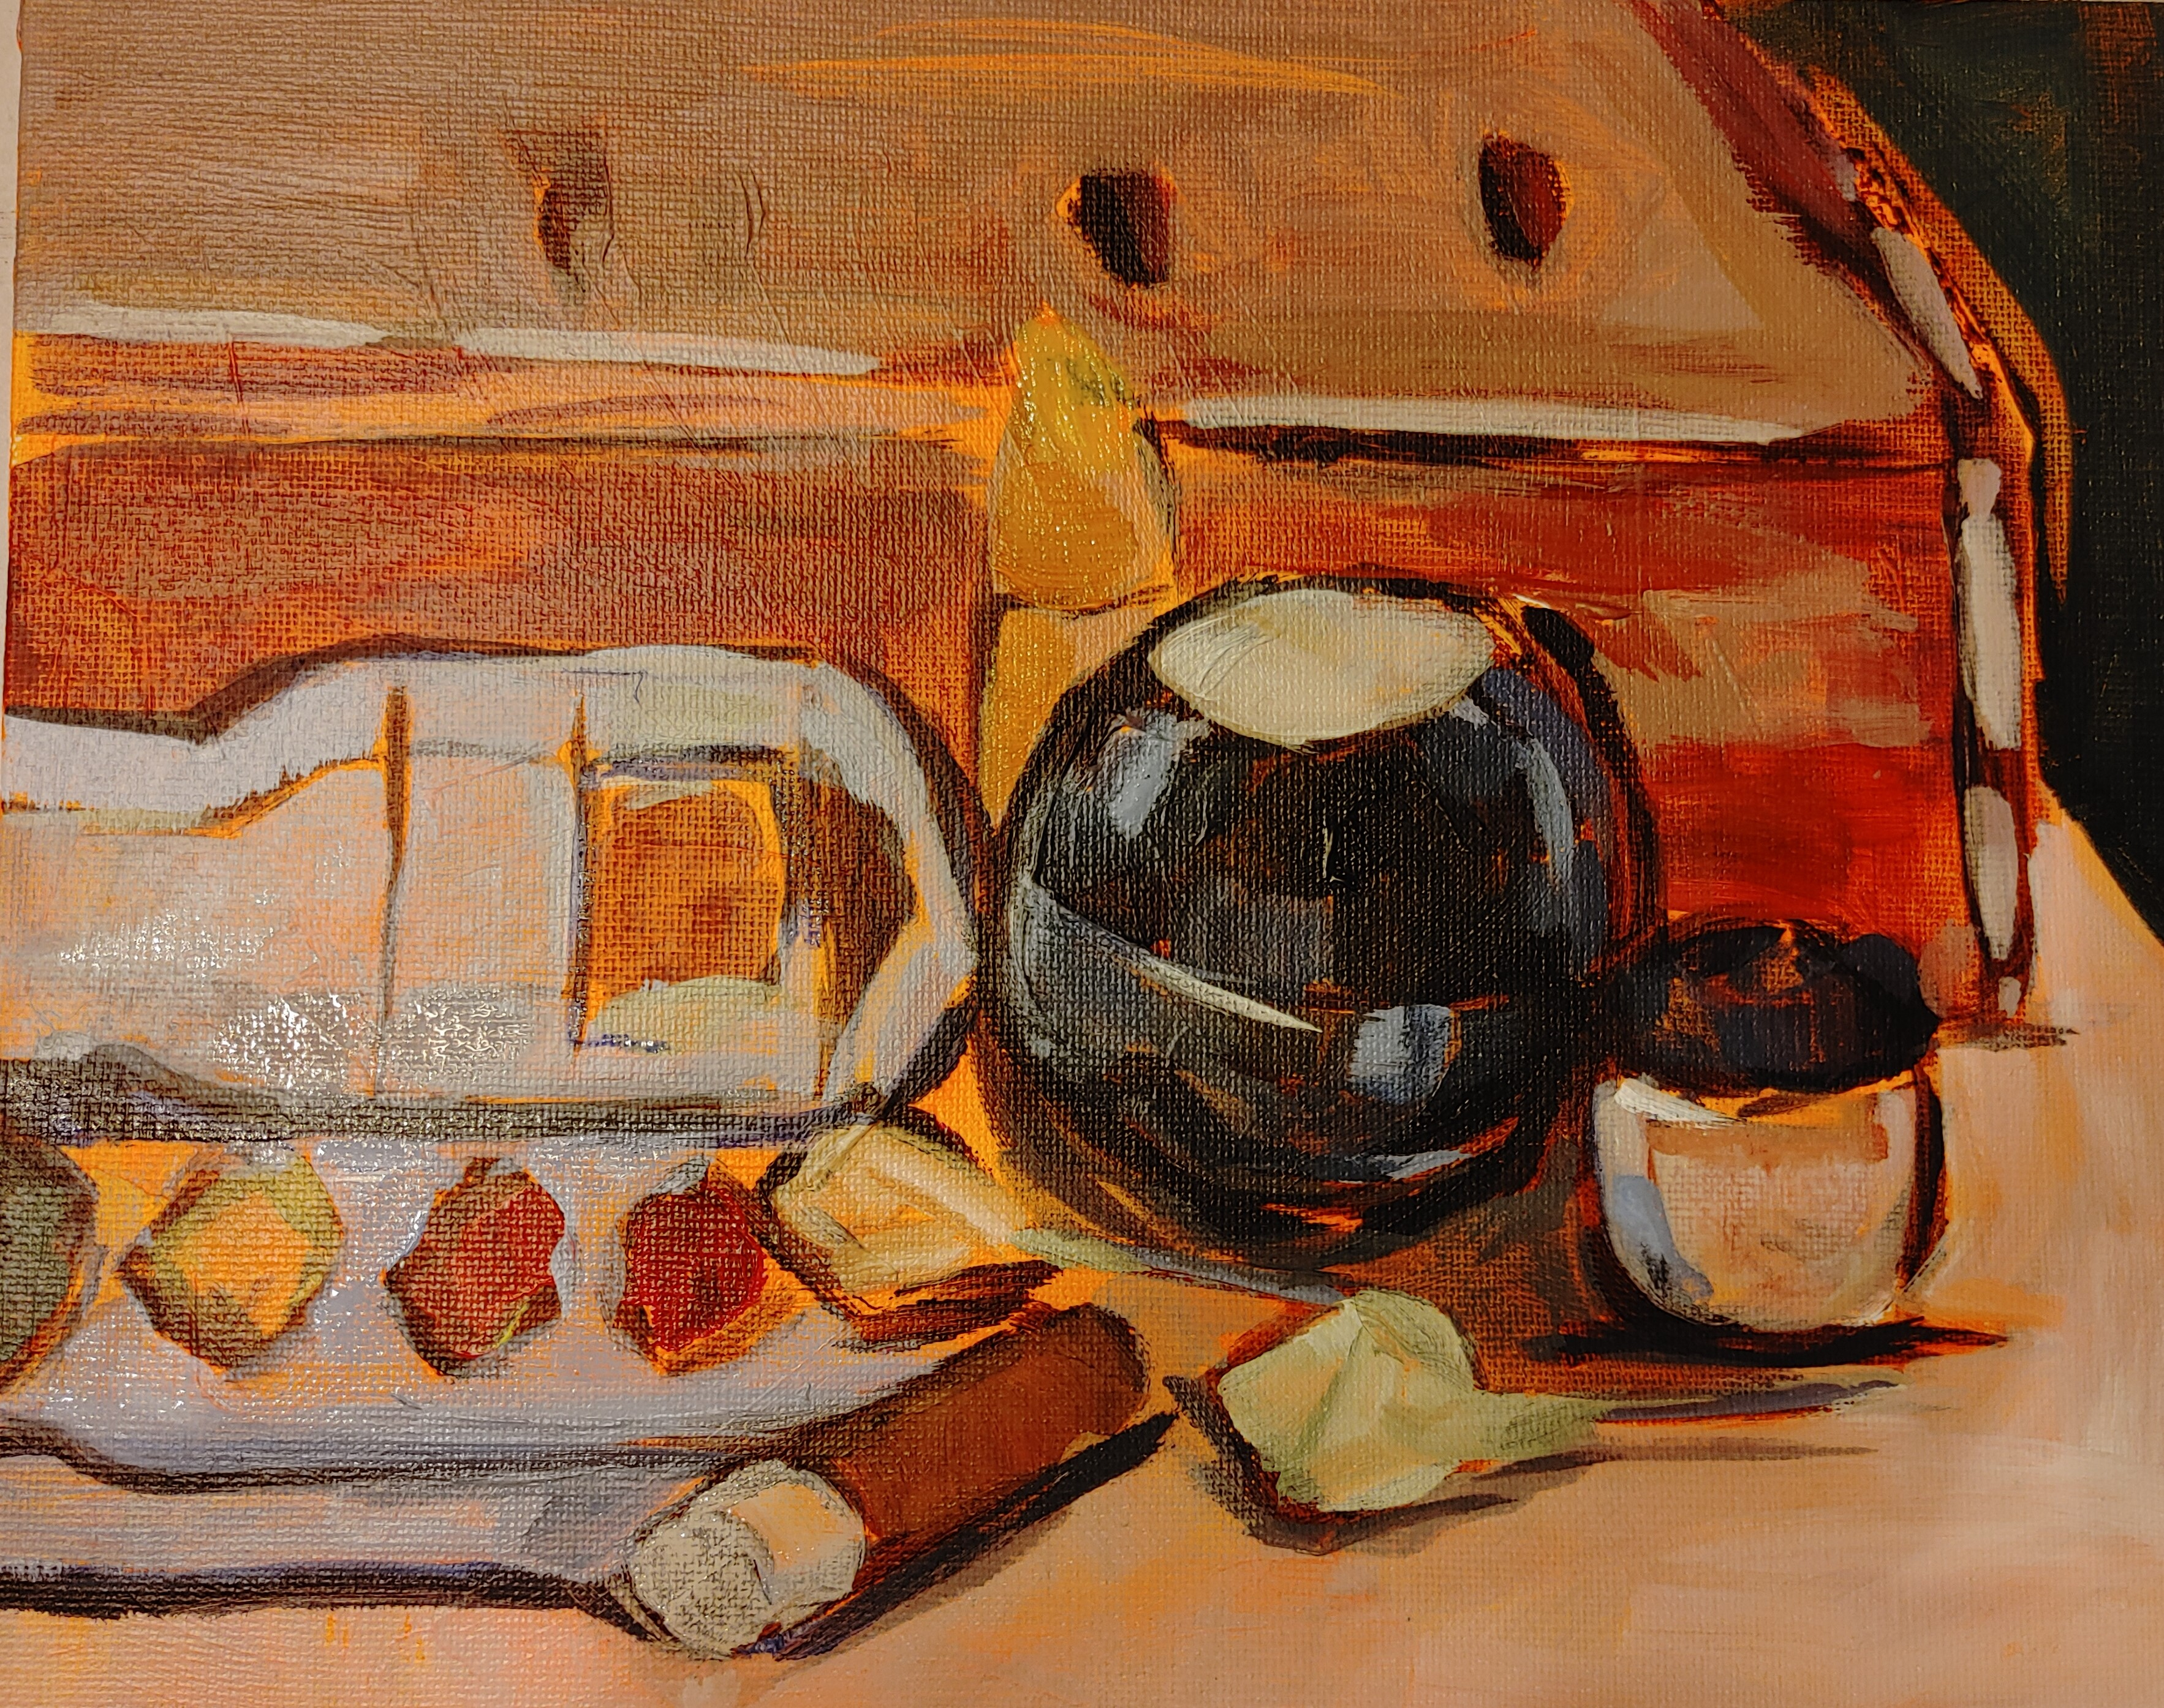
Step 4: Build up layers, increasing saturation of colors to contrast muted undertones.

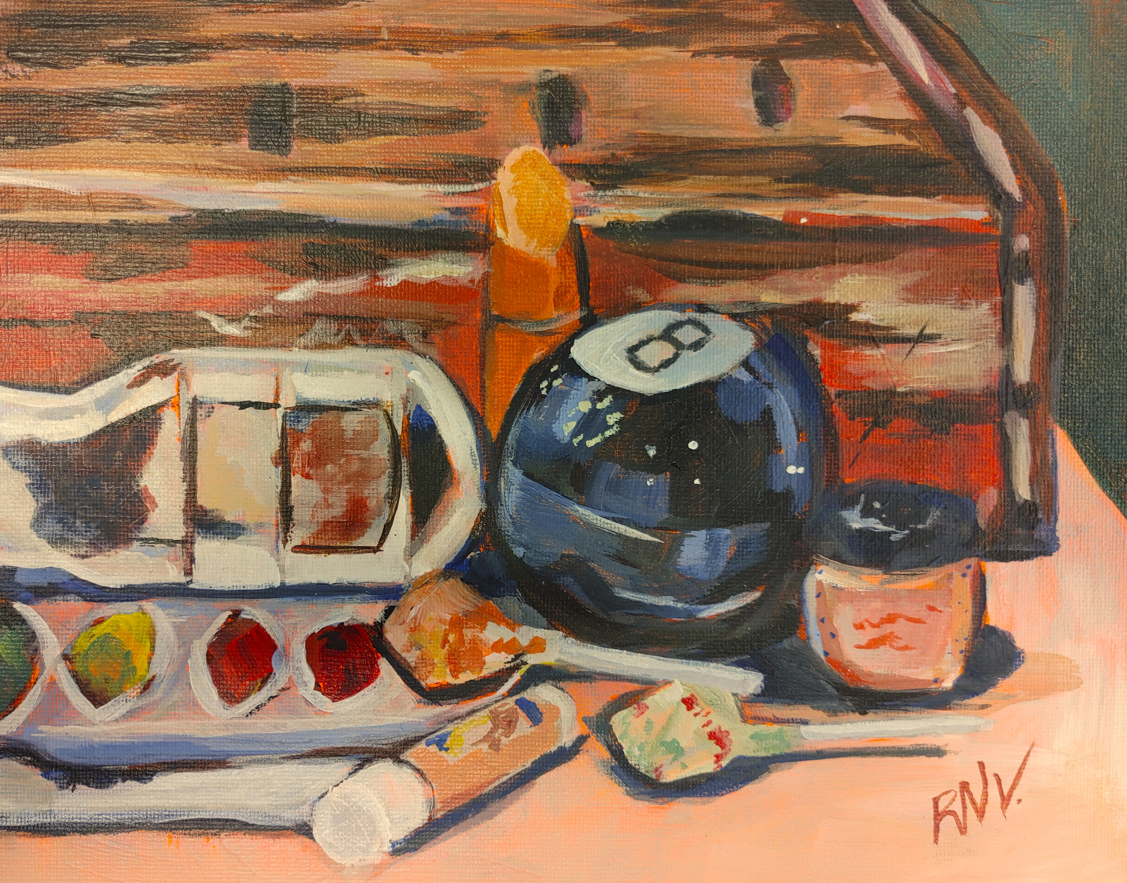
Step 5: continue the layering process to incorporate details including deep shadows and bright highlights.
Student Samples:
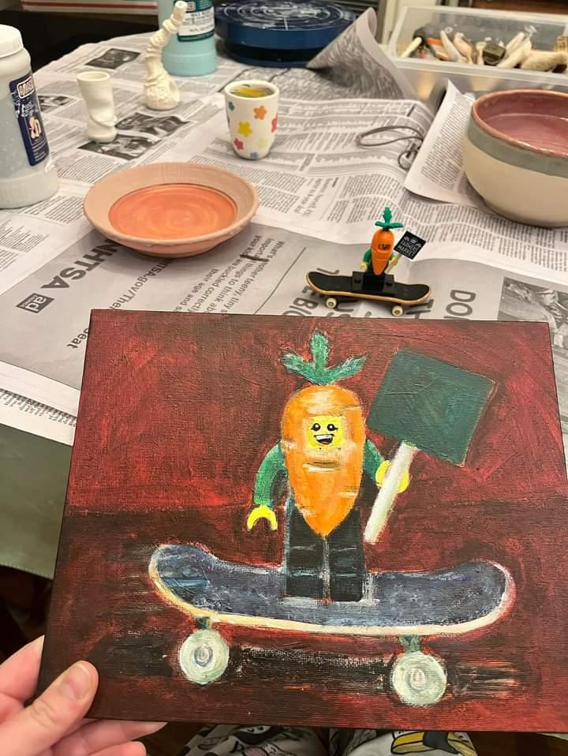
This student chose a Lego person from their childhood and a tech-deck skateboard to invoke nostalgia.
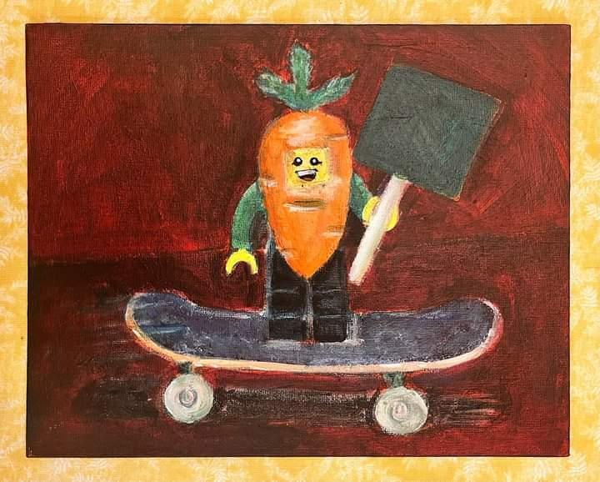 Final Lego-man image.

References
Ganuza, A. (2024). About Alai Ganuza. AlaiGanuza. https://alaiganuza.com/en-us/pages/about-me.
Gergely, J. (2021, November 4). Born in Israel, trained in NY, living in France, artist Guy Yanai defies labels. The Times of Isreal; RGB Media. https://www.timesofisrael.com/born-in-israel-trained-in-ny-living-in-france-artist-guy-yanai-defies-labels/.
Shryack, S. (2024). Gallery - Sari Not Sorry Art by Sari Shryack. Not Sorry ArtTM from Sari Shryack. https://www.sari.studio/about.

